Chapter 18, Solution 37.

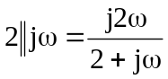

By current division,

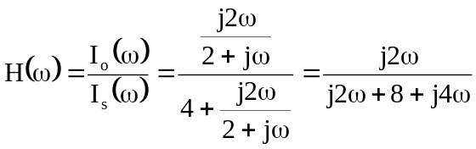

H(ω) = 